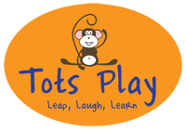
Baby Development Course Questionnaire
Please rate the following aspects of the Baby Development course by circling the answer you feel is most appropriate:
Content of course: | Poor | Average | Good | Excellent
Workbook and CD: | Poor | Average | Good | Excellent
Explanation of subject matter/techniques: | Poor | Average | Good | Excellent
Tutor’s knowledge of subject: | Poor | Average | Good | Excellent
Value for money: | Poor | Average | Good | Excellent
Did you find the course enjoyable?: | No | Reasonably | Yes
Did you find the course beneficial?: | No | Reasonably | Yes
Did the course meet your expectations?: | No | Met expectations | Exceeded expectations
The length of the class was... | Too short | About right | Too long
The length of the course was... | Too short | About right | Too long

What did you enjoy most about the course?

What could have been improved?

What would you have liked to be included in the course that wasn’t?

Your name (optional):

Baby’s age at start of course:

Thank you for your feedback.

